Stance Adjunct

✅ What Is a Stance Adjunct?
# Source: AI Source: Provided by: [Data Path: Persons Table -> ID Column: 1, Name_En Column: Motasem Essam] -> From: [Chatgpt (GPT-4-turbo)] on [8/6/2025]
A stance adjunct (also called a disjunct) expresses the speaker's or writer's attitude, opinion, judgment, or perspective toward the content of the sentence. It conveys how the speaker feels about the truth, necessity, or manner of the statement.
It answers questions like:
- What is the speaker’s opinion or attitude?
- How certain is this?
- Is the speaker evaluating the statement?

🔸 Common Forms of Stance Adjuncts:
# Source: AI Source: Provided by: [Data Path: Persons Table -> ID Column: 1, Name_En Column: Motasem Essam] -> From: [Chatgpt (GPT-4-turbo)] on [8/6/2025]
- Adverbs: frankly, honestly, unfortunately, obviously, apparently, hopefully, surely, clearly, surprisingly
- Phrases: in my opinion, to be honest, as far as I know, to my surprise

🔸 Examples of Stance Adjuncts in Sentences:
# Source: AI Source: Provided by: [Data Path: Persons Table -> ID Column: 1, Name_En Column: Motasem Essam] -> From: [Chatgpt (GPT-4-turbo)] on [8/6/2025]
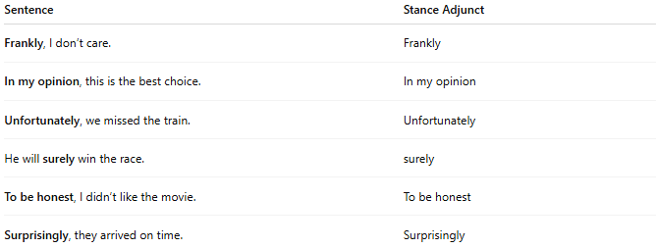
Sentence | Stance Adjunct
Frankly, I don’t care. | Frankly
In my opinion, this is the best choice. | In my opinion
Unfortunately, we missed the train. | Unfortunately
He will surely win the race. | surely
To be honest, I didn’t like the movie. | To be honest
Surprisingly, they arrived on time. | Surprisingly

🔸 Position in the Sentence:
# Source: AI Source: Provided by: [Data Path: Persons Table -> ID Column: 1, Name_En Column: Motasem Essam] -> From: [Chatgpt (GPT-4-turbo)] on [8/6/2025]
- Initial (most common): Hopefully, he’ll make it.
- Medial (less common): He has, surprisingly, improved a lot.
- Final (rare): They will be here soon, hopefully.

🔸 Types of Meaning Expressed by Stance Adjuncts:
# Source: AI Source: Provided by: [Data Path: Persons Table -> ID Column: 1, Name_En Column: Motasem Essam] -> From: [Chatgpt (GPT-4-turbo)] on [8/6/2025]
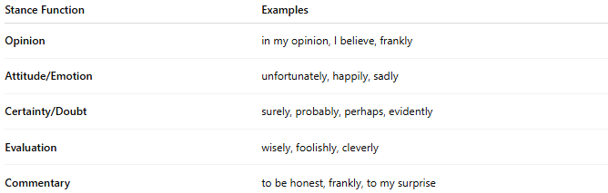
Stance Function | Examples
Opinion | in my opinion, I believe, frankly
Attitude/Emotion | unfortunately, happily, sadly
Certainty/Doubt | surely, probably, perhaps, evidently
Evaluation | wisely, foolishly, cleverly
Commentary | to be honest, frankly, to my surprise

🔸 Reminder:
# Source: AI Source: Provided by: [Data Path: Persons Table -> ID Column: 1, Name_En Column: Motasem Essam] -> From: [Chatgpt (GPT-4-turbo)] on [8/6/2025]
A stance adjunct is not grammatically required but is useful for signaling attitude, tone, or subjectivity.
🟢 "They missed the train."
🟡 "Unfortunately, they missed the train." → Stance adjunct adds emotion/judgment

